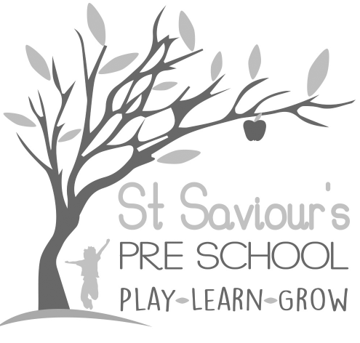
10.6 WORKING IN PARTNERSHIP WITH OTHER AGENCIES

Written by: Claire Toms and Tina Alder Date: 1.09.22 – reviewed 31.8.25

Policy Statement
At St Saviour’s Pre-school and Nursery, we work in partnership with local and national agencies to promote the wellbeing, safety, and learning of all children. We recognise the importance of collaborative working and the sharing of information to ensure children receive the best possible care, early help, and support.

Procedures
- We have clear procedures in place for the sharing of information about children and families with other agencies. These are outlined in our:
  - Information Sharing Policy
  - Safeguarding Children, Young People and Vulnerable Adults Policy
  - Child Rights and Entitlement Policy
  - Supporting Children with Special Educational Needs and Disabilities (SEND) Policy
- Information shared with us by other agencies is regarded as third-party information. This is always kept confidential and is not shared further without the consent of the originating agency, unless legally required.
- When working with staff from other agencies, we:
  - Welcome them into our setting and respect their professional expertise.
  - Follow agreed local protocols and safeguarding procedures, including those set out by Hertfordshire Safeguarding Children Partnership (HSCP).
  - Ensure visiting professionals are appropriately identified, sign in and out of the setting, and wear visitor identification if required.
- Staff from other agencies will not have unsupervised access to children during their visit and will not have access to any children other than those they are specifically visiting.
- Our staff do not casually share information or seek informal advice about any named child or family. Information sharing always follows our formal procedures and respects confidentiality.
- Where appropriate, we consult with and signpost families to local and national agencies that can provide specialist advice, support, and resources, for example:
  - Health Visitors and Speech & Language Therapy services
  - Children’s Centres and Family Support Services
  - Hertfordshire SEND Local Offer
  - Early Years Advisory Teachers
  - National support organisations such as NSPCC, Young Minds, and Contact a Family
- We participate in multi-agency meetings, such as Team Around the Family (TAF), Early Help Assessments (EHA), and Child Protection Conferences, ensuring our contributions are timely, accurate, and focused on the best interests of the child.

Legal and Statutory Framework
- Early Years Foundation Stage (EYFS) 2025 – Safeguarding and Welfare Requirements
- Working Together to Safeguard Children (2023)
- Data Protection Act 2018 & UK GDPR
- Hertfordshire Safeguarding Children Partnership (HSCP) protocols

